Mini Project

# On

**Management Information System for Online Marriage Bureau**

***Submitted as a part of Course Curriculum***

## Masters of Computer Applications



**Submitted to: Submitted By:**

Dr. Gurpreet Singh Josan Ishika Garg (21071208),

Dr. Sukhjeet Kaur Ranade Shairya Sharma (21071225),

Department of Computer Science Ssembuya Abdurahumani (21071291)

MCA (Semester - 2nd)(Sec-A)

## Department of Computer Science Punjabi University, Patiala 147002 Session (2021-2023)

**Candidate’s Declaration**

We hereby declare that the Minor Project work being presented in this report entitles **‘Management Information System for Online Marriage Bureau’** Submitted in the Department of Computer Science, Punjabi University, Patiala. It is Authentic Work carried out by me and my teammates under the guidance of **Dr. Gurpreet Singh Josan**, Asst. Prof Department of Computer Science.

**Date _ _/_ _/_ _ _ _** Ishika Garg **(21071208),**

Shairya Sharma **(21071225),**

Ssembuya Abdurahumani **(21071291)**

**Department of Computer Science**

**Punjabi University Patiala- 147002(PB)**

# Acknowledgement

We would like to take this opportunity to express our gratitude to all those people without whom this project could have never been completed. First and foremost we would like to express deep sense of thanks and gratitude to our mentor, teacher and guide **Dr. Gurpreet Singh Josan,** also He Helped us in doing a lot of Research and We came to know about so many new thing about this Project and we’re really thankful to him.

Ishika Garg **(21071208),**

Shairya Sharma **(21071225),**

Ssembuya Abdurahumani **(21071291)**

Date: - _ _/_ _/_ _ _ _

# Abstract

The purpose of **Management Information System for Online Marriage Bureau** is to automate the existing manual system by the help of computerized equipments and full-fledged computer software, fulfilling their requirements, so that their valuable data/information can be stored for a longer period with easy accessing and manipulation of the same. The required software and hardware are easily available and easy to work with.

Online Matrimonial Site, as described above, can lead to error free, secure, reliable and fast management system. It can assist the user to concentrate on their other activities rather to concentrate on the record keeping. Thus it will help organization in better utilization of resources. The organization can maintain computerized records without redundant entries. That means that one need not be distracted by information that is not relevant, while being able to reach the information.

The aim is to automate its existing manual system by the help of computerized equipments and full-fledged computer software, fulfilling their requirements, so that their valuable data/information can be stored for a longer period with easy accessing and manipulation of the same. Basically the project describes how to manage for good performance and better services for the clients.

## TABLE OF CONTENTS

**SR. No CONTENTS PAGE No.**

### Introduction:

* 1. Purpose
  2. Intended Audience
  3. Product scope 6 - 9
  4. Project Features
  5. Hardware/Software Requirement
  6. Synopsis

### System Development:

* 1. Project Management
  2. System Analysis And Design(DFD) 10 - 15
  3. System Environment

### Design and Implementation:

* 1. Database Design
  2. Snapshots Of System 16 - 24

### Project Legacy:

* 1. Current Status
  2. Problems Faced 25
  3. Limitations
  4. Future Enhancements
  5. Reference

## Introduction

**Purpose:**

The main purpose of this project is to build an application program to reduce the manual work for managing and accelerate the opportunities of providing newer matrimony services for sharing matrimonial information more comfortably and selectively, though often criticized in terms of adequacy and authenticity of such information.

Secured online matrimonial system is designed to overcome the drawbacks of existing system. It also provides fast searching for a life partner and sending his/her contact or communicates with the existing members. As both the members will agree they meet together for the marriage. A person can search for a bride or a groom of any religion of any caste.

## Intended Audience:

Main intended audience of this system is maintained by user. User can perform many tasks at the time like search for a bride/groom and if it seek interest then it send message. So the user can search profile but firstly have to register on that site. So, then it makes very difficult for the user to manage so many things at the same time, although our system helps user to manage these things quite efficiently.

## Project Scope:

Scope of this project is to provide platform to a lot of Bride/Groom for finding perfect match. There are different sectors like Registration, Partner, Search, etc. So the Bride/Groom can get their interest for find their partner. Bride/Groom can directly search Partner according to their required criteria.

## Project Features:

**CROSS PLATFORM COMPATIBILITY: -** Operating Systems like Windows 7, 8.1, 10, Linux are capable of running this project in their system. We can also use Oracle Database to run this.

**INTERACTIVITY: -** Interaction with the project is quite easy, and simple as the frontend design of the project is minimalistic an ergonomic approach is taken here therefore any new user to it can use it easily.

## Hardware/Software Requirement:

* + 1. **Hardware Requirement:**

Memory: Minimum 256 MB RAM Hard Disk Space: 8 GB

Display: 14” LED Monitor

## System Requirement:

Operating System: Windows 7 or Above Front End: HTML, CSS, Bootstrap

Back End: PHP, Xampp Server Text Editor: Visual Studio Code

Browser: Google Chrome, Mozilla Firefox etc

# Synopsis

This project intends to use the latest advancements in technology in **Management Information System for Online Marriage Bureau** regarding marriage and find perfect match. This application is to facilitate matchmaking business by applying the information in the field. It helps the user by providing profiles of Bride/Groom and other information regarding them online.

User can get information regarding their dream life partner at his/her home at his/her convenience. This application also provides a search utility which helps those users who have a certain criteria of qualities in mind to make online matrimonial easier. Since internet is a pivot for modern business, our project which is based on internet paves a path for modernization in trade.

Matrimonial Web Application will allow a new user to register and after successfully registration users profile will be visible to other users. Matrimonial website is providing platform to a lot of Bride/Groom for finding perfect match. There are different sectors like Registration, Partner, Search, etc. So the Bride/Groom can get their interest for find their partner. Bride/Groom can directly search Partner according to their required criteria.

# Benefits:

* Portability: The system is developed to work on any environment so it can be portable.
* Availability: This system will available on any system.
* User Interfaces: The software provides good graphical interface for the user any administrator can operate on the system, performing the required task such as create, update, and viewing the details of firms.

## 1.) Objective of the Project:

# The main objective of Matrimonial Web Application is to provide Grooms and Brides with excellent matchmaking experience by exploring the opportunities and resources to meet true potential partner. Keeping our objective in mind, we have created a world renowned online matchmaking services that will touch the souls of millions of people all over the globe.

# 2.) Project Category:

Web Project

# 3.) Structure of the Project:

### Functionality Performed By the User:

* + - Login
    - Register Profile
    - Partner Preferences
    - Find Bride/Groom

###   Functionality Performed By the Admin:

* + - Updating Login table and user table
    - Retrieve login table , user table , payments and

**System Development**

* 1. **Project Management: Gant Chart**

|  |  |  |  |  |  |  |  |  |  |  |  |  |
| --- | --- | --- | --- | --- | --- | --- | --- | --- | --- | --- | --- | --- |
| **PHASES** | **Day 1** | **Day 3** | **Day 4-9** | **Day 10-15** | | **Day 16-25** | **Day 21-30** | | **Day 30-35** | | **Day 36-41** | |
| **PLANNING** |  | |  | | | | | | | | | |
| **REQUIREMENTS ANALYSIS** |  | |  |  | | | | | | | | |
| **DESIGN** |  | | |  | | |  | | | | | |
| **CODING** |  | | | |  | | | | | |  | |
| **TESTING** |  | | | | | | |  | | | |  |
| **IMPLEMENTATION** |  | | | | | | | | |  | | |

## DATA FLOW DIAGRAMS –

## 1. ZERO LEVEL

## 

## 2. LEVEL 1 DFD

## 

## 3. LEVEL 2 DFD

## 

## ER Diagram (Entity-Relationship Diagram)

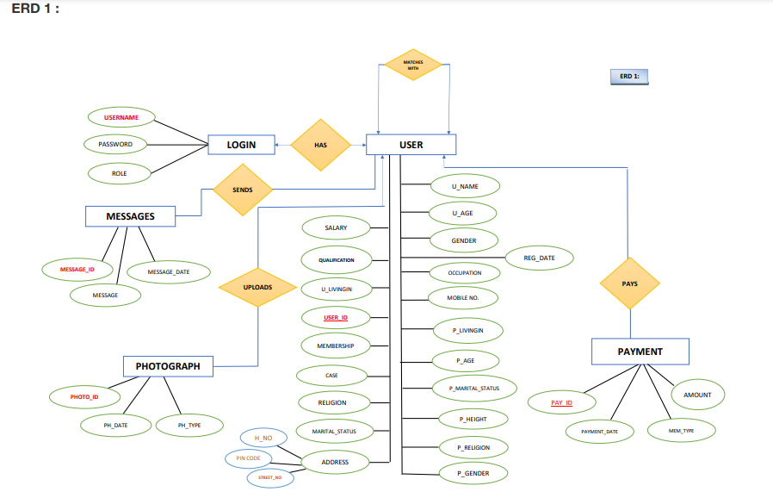

**ERD 2:**

*A*

*DVERTISER*



*ADVERTISE*

*ADVERTISEMENT*

***ADV_NAME***

***ADV_ID***

***DURATION***

***LOCATION***

*ADVT_ID*

**System Environment**

**IDE (Integrated Development Environment)**

The IDE used to develop this project is Visual Studio Code which is developed by Microsoft Corporation. It is a source code editor handy in performing coding of various programming languages. VSC support for debugging, syntax highlighting, intelligent code completion, snippets, code refactoring, and embedded Git. Users can change the theme, keyboard shortcuts, preferences, and install extensions that add additional functionality.

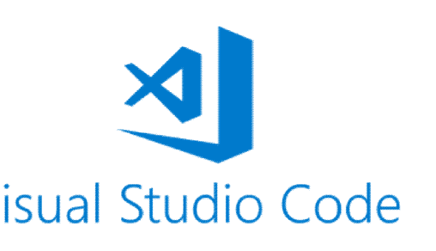

## Database Used

To develop this project we used ORACLE DATABASE 18C EXPRESS EDITION. Our Oracle tutorial is designed for beginners and professionals. Our Oracle tutorial includes all topics of Oracle database such as insert record, update record, delete record, select record, create table, drop table etc. There are also given Oracle interview questions to help you better understand the oracle data base.

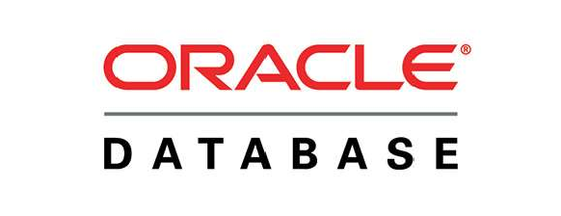

## 2.3.2 Back End Programming Language

As a back end programming language PHP is used in this project. PHP is an open-source, interpreted, and object-oriented scripting language that can be executed at the server-side. PHP is well suited for web development. Therefore, it is used to develop web applications (an application that executes on the server and generates the dynamic page).

## DESIGN AND IMPLEMENTATION

**Database Design Relational Table:**

**1st Table:-**

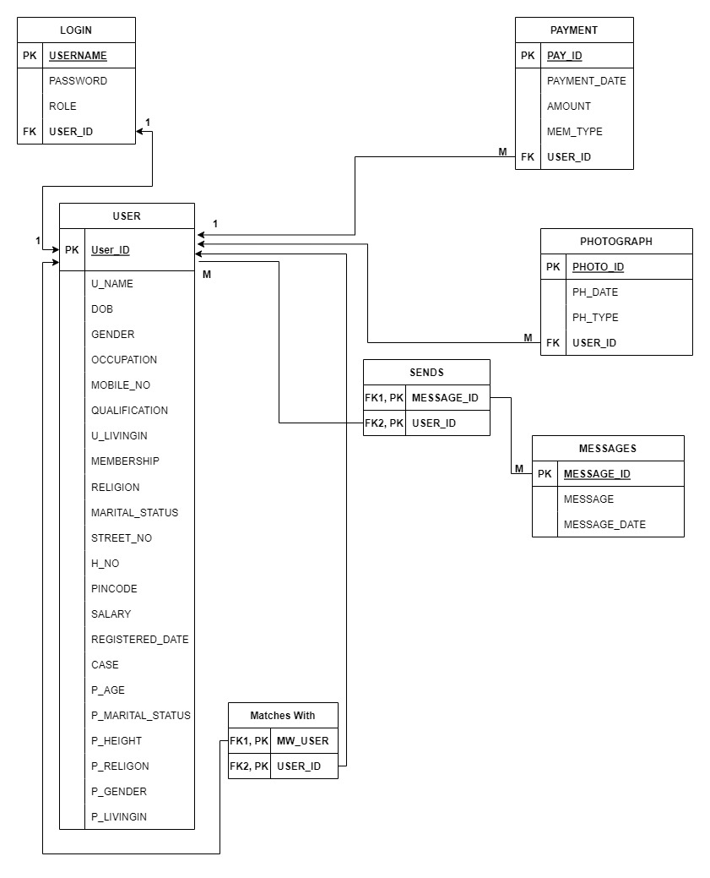

**2nd Table:-**

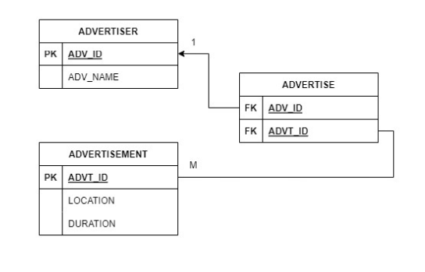

## SNAP SHOTS

## 

## LOGIN AS ADMIN :

## 

## 

## 

## 

## LOGIN AS USER :

## 

## AFTER SIGN UP : Home Page:-

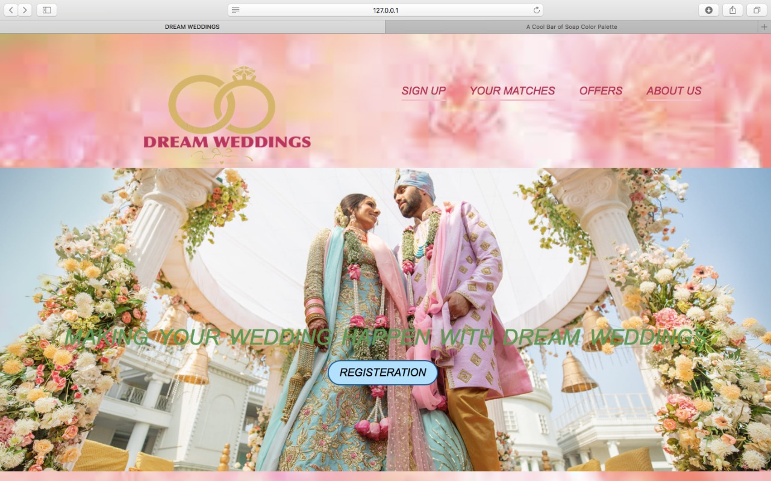



## About us:-

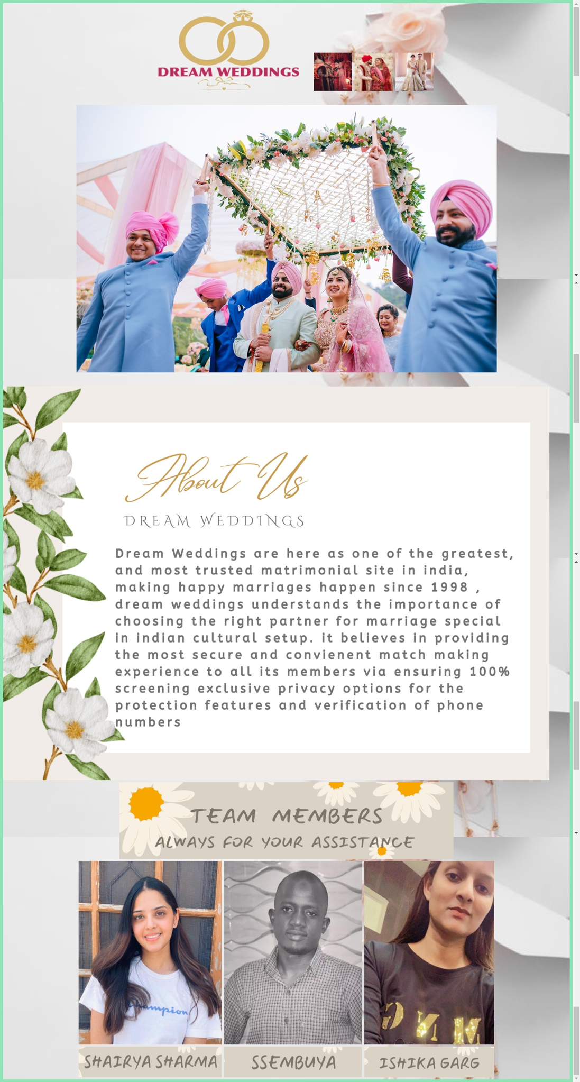

**Register:-**

* + 1. 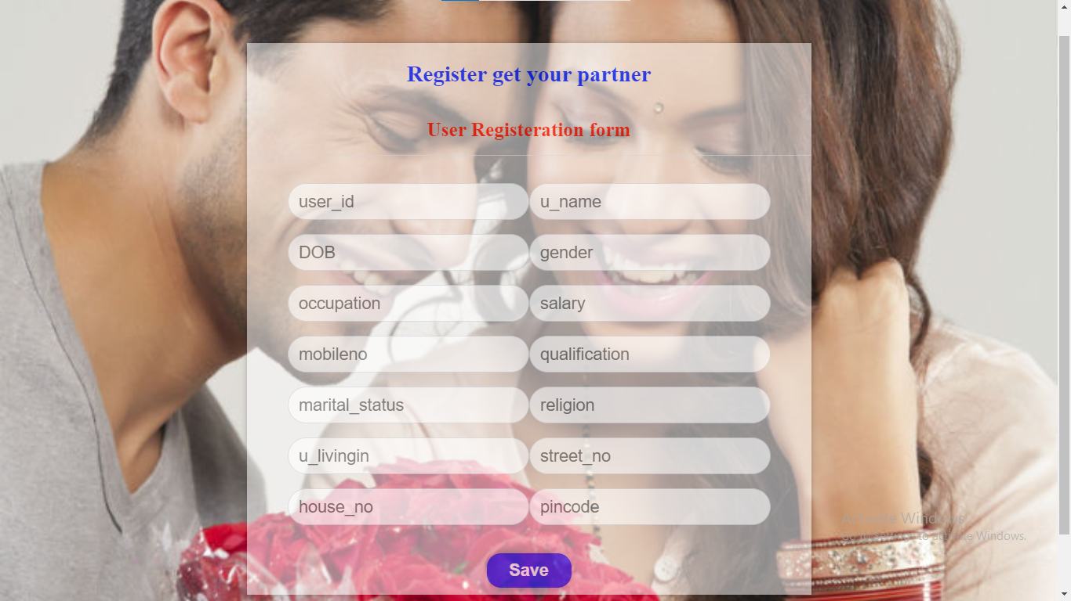

**Register Partner Preferences:-**

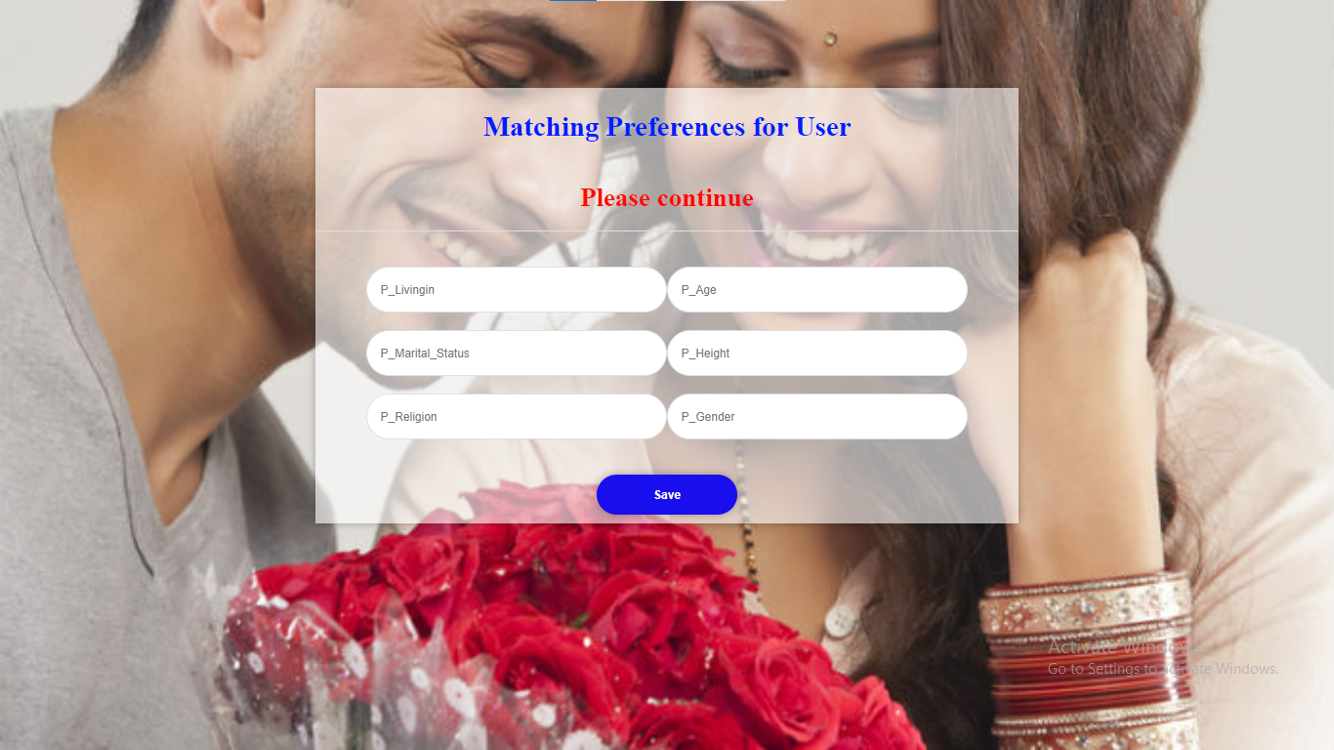

**Login:**

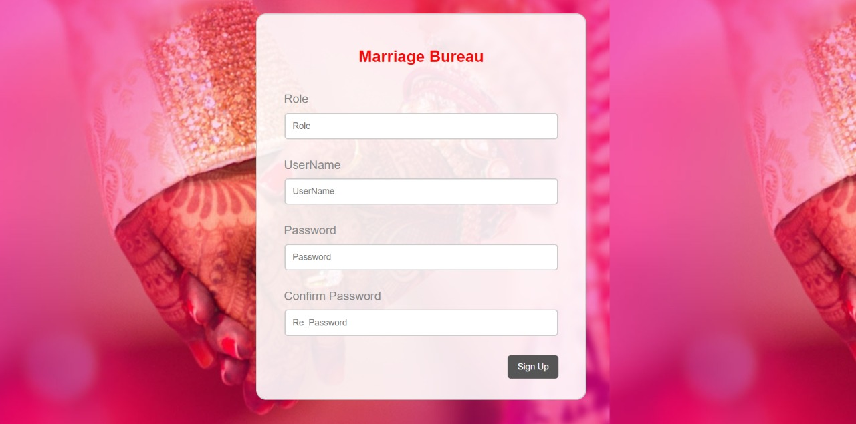

**Bride Details:-**



**Groom Details:-**



## PROJECT LEGACY

**CURRENT STATUS**

Project is completed as per the requirement specification. All functions and operations that are specified are working properly. Currently Some Sales information is added to show the demonstration of the project, similarly few transactions are also added in the project to show its working. And it is further possible to add more data to it and the project is capable of handling all the addition/ subtraction that may be done to this in the future.

## PROBLEM FACED

It is really difficult to connect OCI8 with XAMPP server, because to enable the connection this is the only way to connect oracle with Php, hence viewing all the tutorials we’ve been able to connect our database.

## LIMITATIONS

Till now there are only messages available, further we can give access to video chat or access of any other platforms for further reference.

## FUTURE ENHANCEMENT

In future multiple enhancements can be bringing to this project; in future we can introduce new things to add in this project.

## CONCLUSION

This project is basically to find the perfect potential partner.

## Reference

**https://**[**www.w3schools.com/sql/**](http://www.w3schools.com/sql/)

**https://**[**www.geeksforgeeks.org/bootstrap-tutorials/**](http://www.geeksforgeeks.org/bootstrap-tutorials/)

**https://**[**www.codewithharry.com/**](http://www.codewithharry.com/)**php**